1. Based on my initial design documentation here is a screen print of what was expected for advance search.

Here is a screen shot for what was developed during programming

As you can see, this does not match what I was expecting. Similar, but I think we just need to shift the collapsible search option downward, add a expand symbol, and center the search button.

Before the “advanced search” collapsable link is pressed.

After the “advanced search” collapsible link is pressed

Tenant information

1. Rename page from “Tenant Additional Information” to “Tenant Information”(done)

This was an error on my part, additional information page should be renamed to “Additional Information”

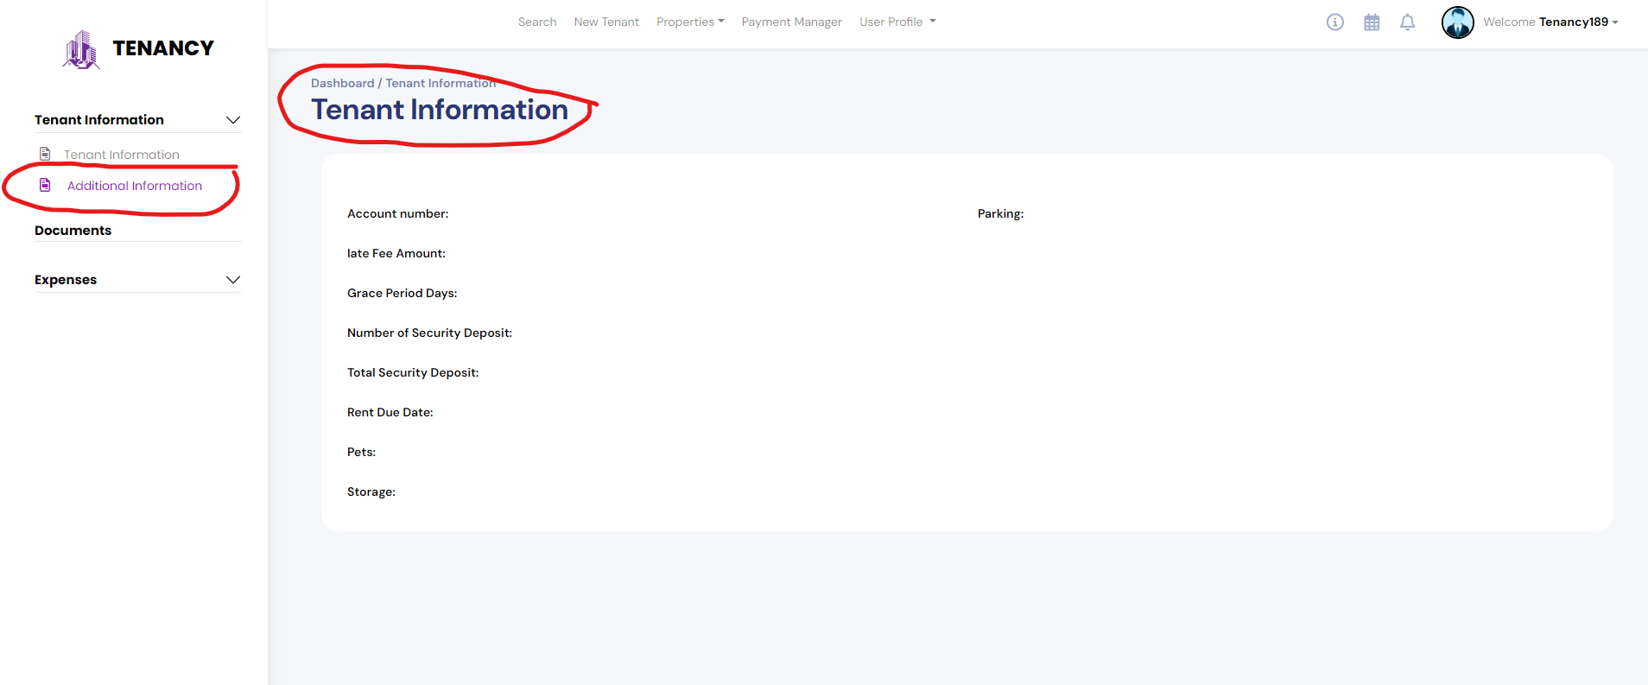

1. Tenant Information – I would like to stay consistent with how the pages function. If you look at the screen shot below for Expenses you will see that Expenses Module has an expenses page and Add Expenses. However, when you look at the screen shot for Tenant information you will see that the tenant information module there is no Tenant information page. Please add a tenant information page under tenant information module and add the information for tenant information there. (done)

This is Good. But can we enhance the user experience to, when a user selects a tenant from search like in the screen shots below, can tenant information module be expanded and Tenant information link highlighted. This way the user will know where they have arrived.

1. A user should not be able to add unit without inserting a unit number. Unit number is a required field.

Response-done

This is not complete. See registered property Test Property for example

Response – I have updated this functionality on add property page please check and let us know if its work ok then we will update it on edit page. Yes this is working good on register property page. Ok to add on edit page. Please update the message from “Please fill out this field” to “Unit number is a required field”

**1.Delete** – Delete Tenant Profile

Since this is a permanent delete to the tenant profile, **we don’t need to unshare any documents before deleting**. However, the application will not delete a tenant profile if there is any **payments** associated under the tenants profile.

Please add the delete link on the edit tenant information page (Bottom Right Corner). Please see below screen shots for more information.

When the user clicks this link then a first confirmation message will display to the user. See below:

If the user wishes to proceed then another confirmation message will appear with more details on the permanent deletion of the tenant profile. See below:

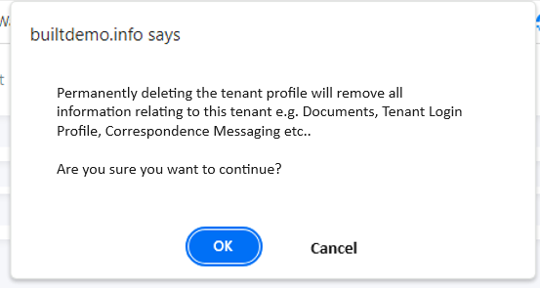

Ok we’ll add the delete functionality once the payment integration setup for tenant.

2.After a tenant is searched and selected, a window box needs to open with that tenant information displaying the tenant information. This box should have the ability to be closed. The box should open for all searched tenants. These small window boxes should connect to tenant information, documents, correspondence, Payments, etc.

Response – Could you clarify if you need the popup to appear for every tenant you've clicked on? Please elaborate the functionality.

Yes, just like in the screen shot below. The maximum popups can be 8

Query. could you please clarify the whole process. I would like to discuss this on a conference call.

1. NEW - When I tab down to cancel button on register new property the cancel button goes invisible

1. NEW Remove unit/Save Changes – The remove units button/ Save Changes button is not working together. During testing, I removed a unit, then left the page, then came back to the unit and the unit was missing. A screenshot of a computer

   Description automatically generated

Response -when you clicked on the remove link it will remove that unit from the database if no tenant is assigned to that unit. And save button is to submit the entire property form.

That is not correct. If the user has registered this property and added these units during the registration process, then clicking on remove unit alone without saving should not automatically remove these units from the database without save.

Instead, if no tenant is registered to the unit and the user selects remove unit, the application should gray out that entire unit or units until the save button is pressed. Once the save button is pressed then a message should appear that says “Are you sure that you want to save the changes to this property?” Ok or Cancel. If the user selects okay, then the application should remove the unit. If the user selects cancel then the entire unit or units should no longer be greyed out.